Polynesian Culture
Student’s Name
Institutional Affiliations

Polynesian Culture
Polynesians are a group of people that live in the central and South Pacific Ocean (Buck, 2017). This group of people practices a unique culture that can mostly be attributed to the environment or surroundings that they live in and the beliefs that they have observed for several years. The Polynesian methodology or cultural narrative contains the cultural beliefs, traditions and values since ancient times.
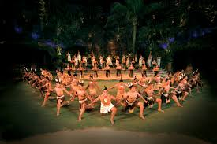

Their religion advocates for a close personal connection to the deities and various demigods that are found in their culture. They believe that all the things that exist in nature do so due to the existence of a supernatural power referred to as Mana (Gunson, 2017). The power that is portrayed to the people is either good or evil and this is manifested in different people, objects or animals. They worship their gods through chants and prayers which are done through the undertaking of sacrifices and rituals.
The Polynesian people mainly rely on the ocean for them to undertake their economic activities. They carry out fishing activities in order to get food for consumption and also use most of the available materials from near the ocean to carve out various sculptures o weave out baskets. This is something that is sold to most of the tourists who visit the area and thus enables them to get some money. They are highly skilled when it comes to navigating in waters and this has helped them to a great extent to achieve their economic activities (Buck, 2017)
Polynesian culture encourages the issue of people having families. They believe that the family is the most important unit and therefore, it is critical for the members of the community to get married (Kahn, Kiste & Suggs, 2018). This is also important for them to discourage the issues of people engaging in sexual intercourse anyhow and thus prevent themselves from contracting diseases. The Polynesian people are strict when it comes to the issue of sexual intercourse before marriage. They require that girls preserve themselves until the time that they are married off. The husbands are required to confirm that the girls are indeed virgins at the time of marriage.
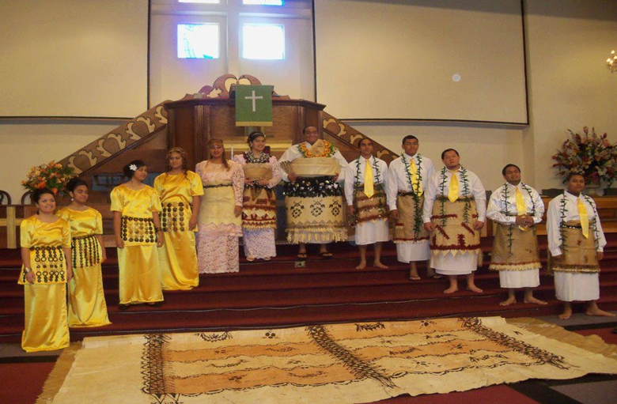
The culture of the Polynesian does not mainly involve political alignment that is witnessed in several other cultures. They observe their leadership through the use of the older people in the society who come up with rules and regulations that guide the community. All the disputes that may arise within the community members are handled by these people and this helps to promote law and order within the community (Gunson, 2017).
The community members mostly spend their leisure activities on the ocean either swimming or taking strolls around the shores of the ocean. They basically do not have several different forms of leisure as they practice it by taking care of their environment, given that they are a bit far from the rest of the society. They also utilize most of their time in creating different forms of art that define their culture (Ritchie & Ritchie, 2018). The arts contain several symbolic meanings attached to them and this is important in identifying the unique culture that they have.
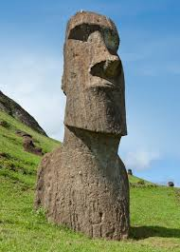

The community does not engage much in holiday issues but instead have several days that are dedicated to certain aspects of the community. The days are used to observe various symbolic meanings such as passing rites and birth naming. They conduct ceremonies to mark the important days and this in one way or another signify the form of holidays that they may have in the community. Their most unique culture is their ability to navigate in deep waters as compared to other cultures (Buck, 2017). This is a unique feature that they have and which enables them to survive in the environment that they are in.

References
Buck, P. H. (2017). The value of tradition in Polynesian research. In Peoples of the Pacific (pp. 155-177). Routledge.
Gunson, N. (2017). Understanding Polynesian traditional history. In Peoples of the Pacific (pp. 179-198). Routledge.
Kahn, M., Kiste, R. C., & Suggs, R. C. (2018). Polynesian culture.
Ritchie, J., & Ritchie, J. (2018). The Polynesian Context. Child Abuse and Neglect: Cross-Cultural Perspectives, 186.

